**Solutions Calculator Club**

**Project Documentation**

**RAM Module**

**MAR, RAM Program Counter Module Circuit Function**:

The MAR has 16 memory locations, each containing 8 bits. The processor has two register, 8-bit memory registers, labeled A and used to temporarily store and manipulate values. Data can be stored in memory as binary values and programs can be stored in memory too. An ID is assigned to each instruction supported by the CPU.

The first four bits store the “operation code”, or opcode for short. The final four bits specify where the data for that operation should come from; this could be registers or an address in memory. First register keeps track of where we are in a program. This is the instruction address register, which stores the memory address of the current instruction. The other register is to store the current instruction, which is called the instruction register.

The User Defines the Run Mode or the Program Mode.

**Program Mode:**

When in Program Mode the Address can be assigned With the 4 pin dip switch in the MAR.

The Value of the data at the ADDRESS is entered using the 8 pin Dip Switch to represent the 8 bit binary value. This can be an OPT Code or a binary coded Decimal value used in the ALU.This is Store in the 64-Bits of Ram on the 74189 IC

**Run Mode:**

The MAR is responsible for Selecting the ADDRESSES when instructed in RUN Mode.

The MAR’s transceiver chip receives Control signal (MI) memory in and Data from the program counter out.

This calls the address of the RAM and the value stored in the 64-Bits of Ram on the 74189 IC at that address. On the Control (RO) RAM OUT sends data to the BUS.

Control (RI) RAM IN Values are written to the address on the MAR.

**MAR’s** main components are 74LS157 (Quad 2 to 1 Selector/Multiplexer), 74LS173 (4-Bit D Register) and Dip_Switch_x4.

**INPUTS:**

**74LS173 (4-Bit D Register)**

***CLR*** IN pin 15 Mr

***CLK*** IN Pin 7 CLK

***NOT (MI)*** Pin 9 and 10

Bus_0 to PIN 11 D3, Bus_ to PIN 12 D2, Bus_2 to PIN 13 D1, Bus_3 to PIN 14 D0.

**74LS157 (Quad 2 to 1 Selector/Multiplexer)**

Pin 1 VCC through RED LED D48

VCC to Ground through Green LED D49

Dip_Switch_x4 Pin 1 to Pin 11 0d

Dip_Switch_x4 Pin 2 to Pin 14 0c

Dip_Switch_x4 Pin 6 to Pin 5 0b

Dip_Switch_x4 Pin 5 to Pin 2 0a

**OUTPUTS:**

**74LS173 (4-Bit D Register)**

Pin 6 Q3 to pin 10 1d 74LS157 (Quad 2 to 1 Selector/Multiplexer)

Pin 5 Q2 to pin 13 1c 74LS157 (Quad 2 to 1 Selector/Multiplexer)

Pin 4 Q1 to pin 6 1b 74LS157 (Quad 2 to 1 Selector/Multiplexer)

Pin 3 Q0 to pin 3 1a 74LS157 (Quad 2 to 1 Selector/Multiplexer)

**74LS157 (Quad 2 to 1 Selector/Multiplexer)**

Za pin 4 Yellow LED44 and A3 IN

Zb pin 7 Yellow LED45 and A2 IN

Zc pin 12 Yellow LED46 and A1 IN

Zd pin 9 Yellow LED47 and A0 IN

The **RAM** circuit’s main components are 74LS00 (Quad NAND gate), 74LS04 (Hex

Inverter), 74LS157 (Quad 2 to 1 Selector/Multiplexer), 74189 (64-bit RAM), 74LS245 (Octal Bus Transceiver) and Dip_Switch_x8

| **INPUTS** | **OUTPUTS:** |
| --- | --- |
| A0 | A0 |
| A1 | A1 |
| A2 | A2 |
| A3 | A3 |
|  | A4 |
|  | A5 |
|  | A6 |
|  | A7 |

**Program Counter**  has integrated circuits the 74LS161 (4-Bit Binary Counter) and 74LS245 (Octal Bus Transceiver).

**INPUTS:**

The Program Counter is incremented on Control Logical Signal (CE) Chip Enable.

**OUTPUTS:**

When Control Logic issues (CO) to the 74LS245 (Octal Bus Transceiver) the Counters state is sent to (MI) Memory In.

**MAR Circuit Schematic:**

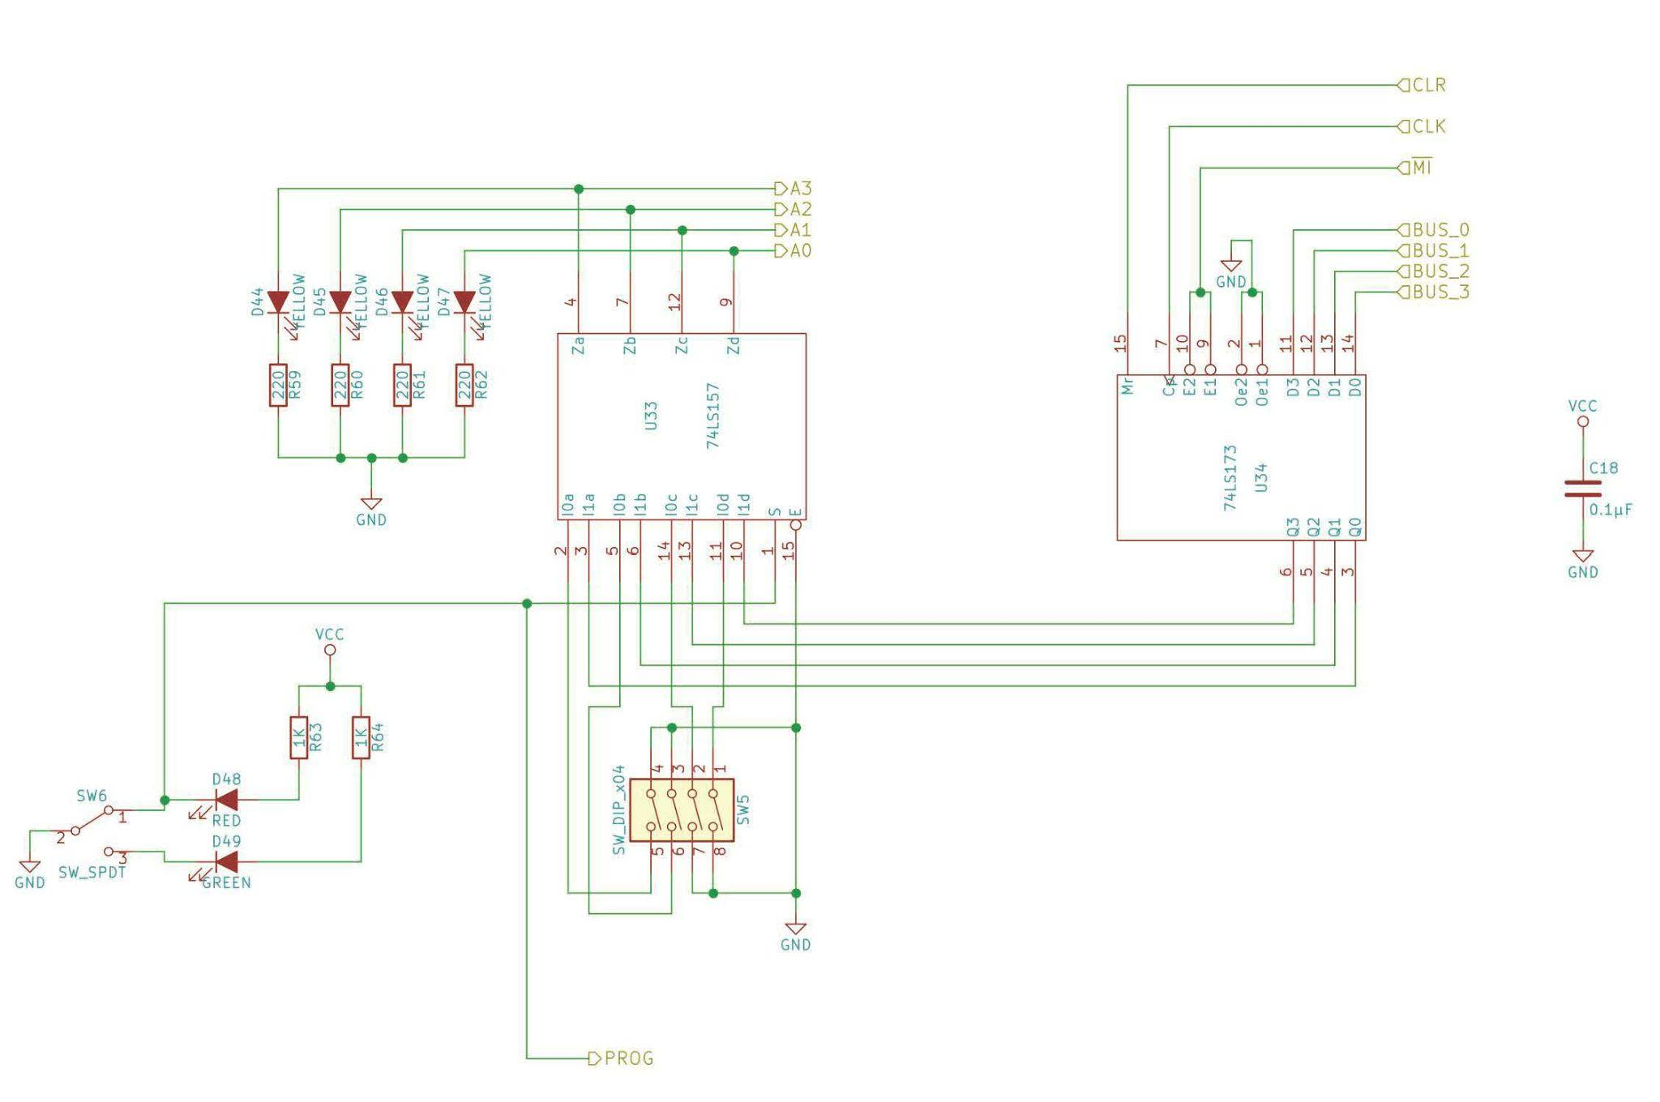

**MAR Parts List:**

| Memory Address Register Module: | | | | | |
| --- | --- | --- | --- | --- | --- |
|  | QN | QIn | **DigiKey Part Number** | **Description** | **Alternate Part** |
|  | 1 |  | 1988-1060-ND | Breadboard |  |
|  | 1 |  | 296-1645-5-ND  74F189PC-ND | [74LS157 Quad 2-to-1 selectors/multiplexer](https://eater.net/datasheets/74ls157.pdf) | SN74HC157N |
|  | 1 |  | 296-33970-5-ND | [74LS173 4-bit D register](https://eater.net/datasheets/74ls173.pdf) |  |
|  | 2 |  |  | 1kΩ resistor |  |
|  | 6 |  |  | 220Ω resistor |  |
|  | 4 | N |  | Yellow LED |  |
|  | 1 | N |  | Green LED |  |
|  | 1 | N |  | Red LED |  |
|  | 1 |  |  | SW_SPDT |  |
|  | 1 |  |  | 4-position DIP switch |  |
|  | 1 |  |  | 0.1µF capacitor |  |

**RAM Circuit Schematic:**

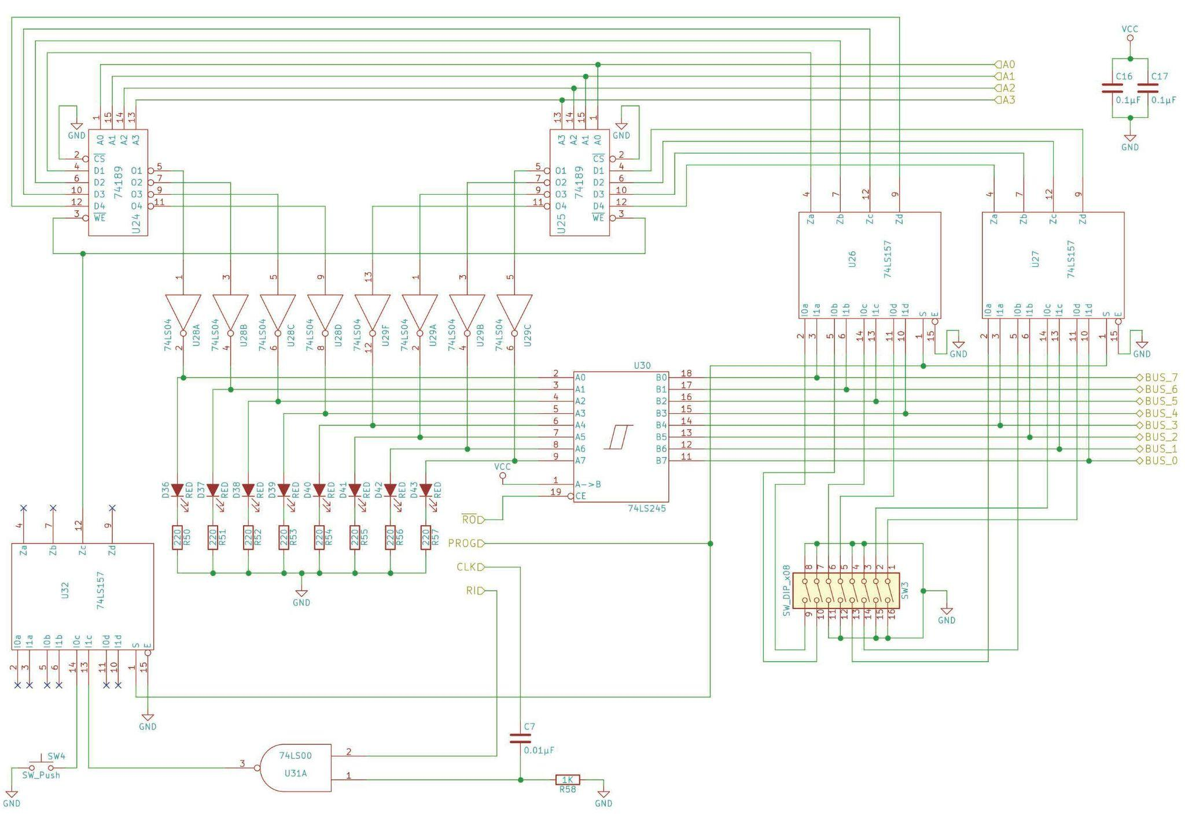

**RAM Parts List:**

| RAM Module: | | | | | |
| --- | --- | --- | --- | --- | --- |
|  | QN | QIn | **DigiKey Part Number** | **Description** | **Alternate Part** |
|  | 1 |  | 1988-1060-ND | Breadboard |  |
|  | 1 |  | 296-1626-ND | [74LS00 Quad NAND gate](https://eater.net/datasheets/74ls00.pdf) |  |
|  | 2 |  | 296-1629-5-ND | [74LS04 Hex inverter](https://eater.net/datasheets/74ls04.pdf) |  |
|  | 3 |  | 296-1645-5-ND  74F189PC-ND | [74LS157 Quad 2-to-1 selectors/multiplexer](https://eater.net/datasheets/74ls157.pdf) | SN74HC157N |
|  | 2 |  | 74F189PC-ND | [74189 64-bit RAM](https://eater.net/datasheets/74189.pdf) |  |
|  | 1 |  | 296-1655-5-ND | [74LS245 8-bit bus transceiver](https://eater.net/datasheets/74ls245.pdf) |  |
|  | 1 |  |  | 1kΩ resistor |  |
|  | 8 |  |  | 220Ω resistor |  |
|  | 8 | N |  | Red LED |  |
|  | 2 |  |  | 0.1µF capacitor |  |
|  | 1 |  |  | 0.01µF capacitor |  |
| * 1 | 1 |  |  | SW_Push |  |

**Program Counter Circuit Schematic:**

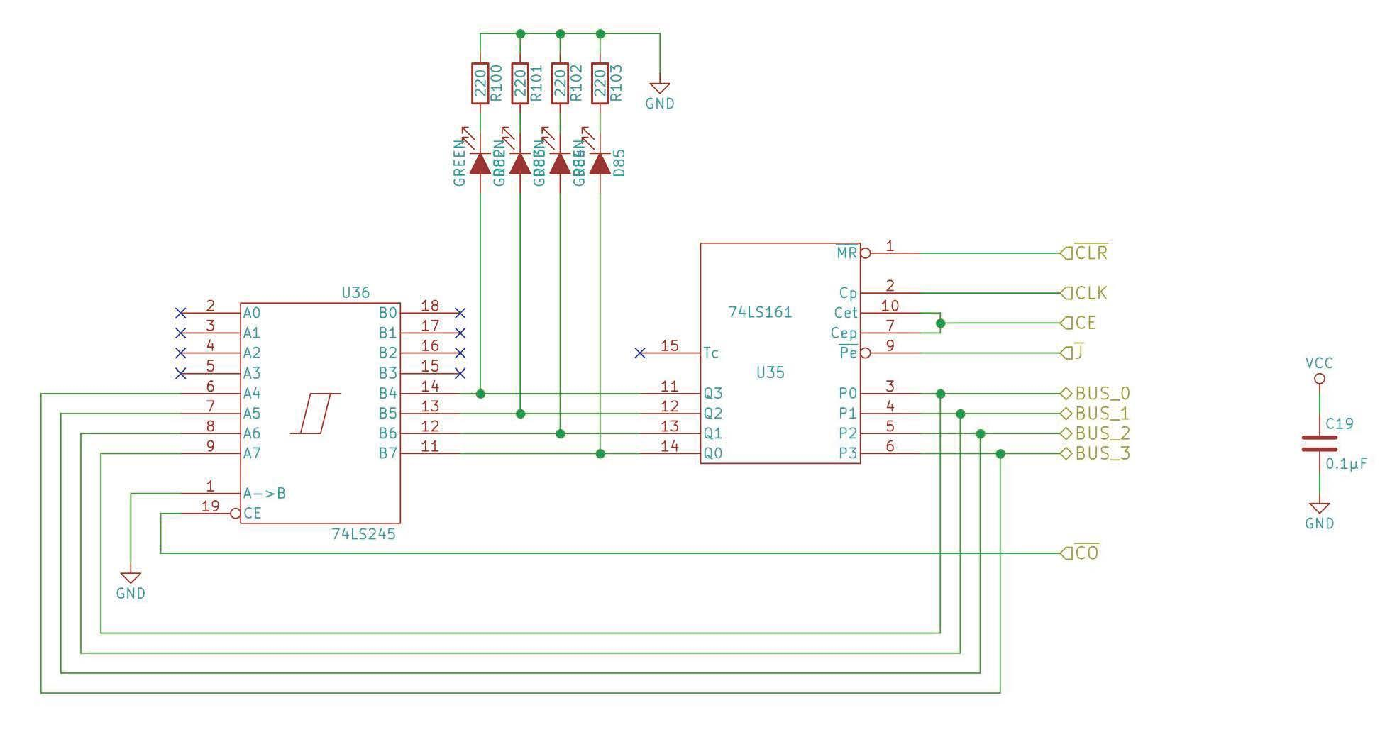

**Program Counter Parts List:**

| Program Counter Module: | | | | | |
| --- | --- | --- | --- | --- | --- |
|  | QN | QIn | **DigiKey Part Number** | **Description** | **Alternate Part** |
|  | 1 |  | 1988-1060-ND | Breadboard |  |
|  | 1 |  | 296-1646-5-ND | [74LS161 4-bit binary counter](https://eater.net/datasheets/74ls161.pdf) |  |
|  | 1 |  | 296-1655-5-ND | [74LS245 8-bit bus transceiver](https://eater.net/datasheets/74ls245.pdf) |  |
|  | 4 |  |  | 220Ω resistor |  |
|  | 4 | N |  | Green LED |  |
|  | 1 |  |  | 0.1µF capacitor |  |